**CSS**

**1.WHAT IS CSS OR WHY CSS CHOOSEN.**

**CSS IS USED TO ADD STYLE TO THE CONTENT OF A WEB PAGE.**

**2.SELECTORS**

**ELEMENT SELECTOR**

**CLASS SELECTOR**

**ID SELECTOR**

**GROUPING SELECTOR**

**UNIVERSAL SELECTOR**

**COMBINATOR SELECTOR**

**PSUEDO ELEMENTS**

**PSEUDO CLASSES**

**ATTRIBUTE SELECOTRS**

**3.HOW MANY WAYS CAN YOU APPLY CSS?**

**INLINE**

**INTERNAL**

**EXTERNAL**

**4.CAN MARGIN TAKE NEGATIVE VALUES?**

**YES, IT WILL TAKE.**

**5.CAN PADDING TAKE NEGATIVE VALUES?**

**NO, IT WON’T TAKE.**

**6.HOW TO CENTER “DIV” HORIZONTALLY?**

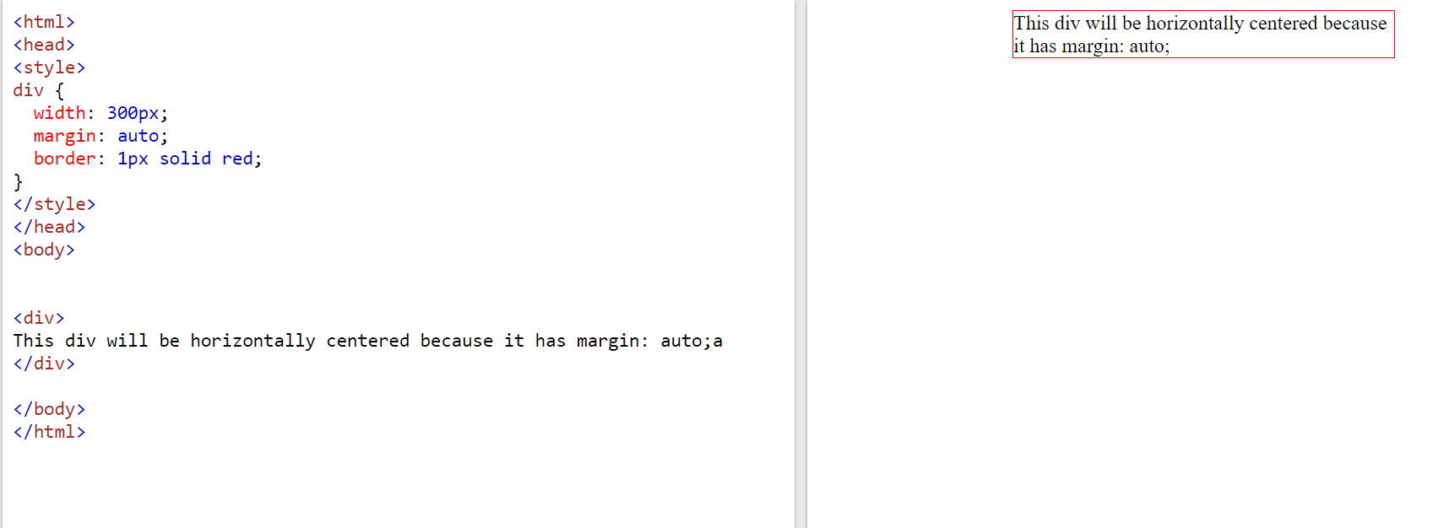

**7.MARGIN COLLPASE IN CSS?**

TOP AND BOTTOM MARGINS OF ELEMENTS COLLPASED INTO SINGLE MARGIN THAT IS EQUAL TO THE LARGEST OF THE TWO MARGINS.

THIS DOES NOT HAPPEN ON LEFT AND RIGHT MARGINS! ONLY TOP AND BOTTOM MARGINS.

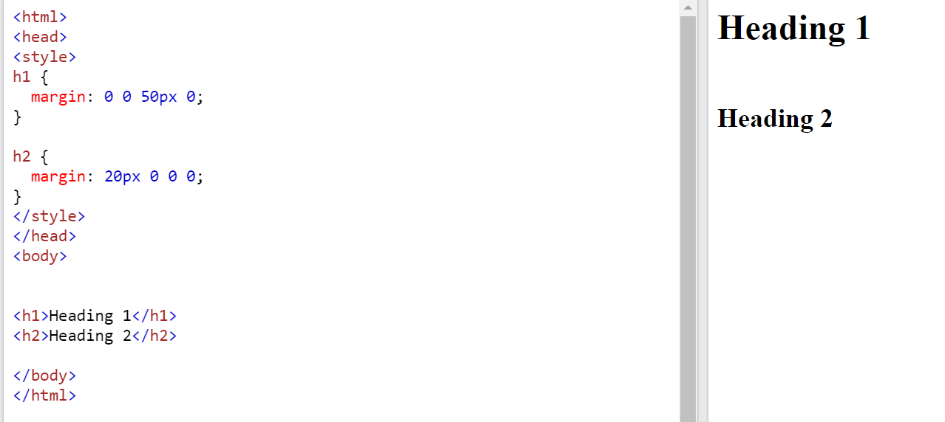

8.WHAT IS BOX-MODEL

BOXMODEL ALLOWS US TO ADD BORDER AROUND ELEMENTS AND DEFINE SPACE BET­­WEEN ELEMENTS.

CONTENT

PADDING

BORDER

MARGIN

9.WHAT IS DIFFRENCE BETWEEN “DISPLAY: NONE” VS “VISIBILITY: HIDDEN”.

“DISPLAY: NONE” MEANS TO HIDE THE CONTENT AS WELL AS SPACE.

“VISIBILITY: HIDDEN” MEANS IT WILL HIDE ONLY CONTENT.

10.CSS POSITIONS.

STATIC

FIXED

STICKY

ABSOLUTE

RELATIVE

STATIC

HTML ELEMENTS ARE POSITIONED STATIC BY DEFAULT.

STATIC POSITIONED ELEMENTS ARE NOT AFFECTED BY THE TOP, BOTTOM, LEFT, RIGHT, MARGIN.

RELATIVE

IT IS POSITIONED RELATIVE TO ITS NORMAL POSITION.

FIXED

IT IS POSITIONED RELATIVE TO THE VIEWPORT.

IT ALWAYS STAYS SAME PAGE EVEN PAGE IS SCROLLED.

STICKY

IT IS POSITIONED BASED ON SCROLL POSITION.

ABSOLUTE

IT IS POSITIONED RELATIVE TO THE NEAREST POSITIONED ANCESTORS.

IF AN ABSOLUTE POSITIONED ELEMENTS HAS NO POSITIONED ANCESTORS. IT USES THE DOCUMENT BODY.

11.Z-INDEX

Z-INDEX SPECIFIES THE STACK ORDER OF AN ELEMENT.

Z-INDEX ONLY WORKS ON POSITIONED ELEMENTS. (ABSOLUTE, RELATIVE, FIXED, STICKY)

12.DIFFERENCE BETWEEN INLINE VS INLINE-BLOCK.

BOTH ARE SAME. BUT INLINE-BLOCK WILL TAKE WIDTH, HEIGHT, MARGIN-TOP, MARGIN-BOTTOM.

13.COMBINATOR SELECTORS

DESENDANT SELECTOR(SPACE)

CHILD SELECTOR (>)

ADJACENT SIBLING SELECTOR (+)

GENERAL SIBLING SELECTOR (~)

14. PSEUDO ELEMENTS

AFTER

BEFORE

FIRST-LETTER

FIRST-LINE

SELECTION

MARKER

15.PSEUDO CLASSES

ACTIVE

HOVER

LINK

VISITED

CHECKED

DISABLED

FIRST-OF-TYPE

LAST-OF-TYPE

FIRST-CHILD

LAST-CHILD

16.OPACITY

OPACITY PROPERTY SPECIFIES THE TRANSPERNCY OF AN ELEMENT.

OPACITY CAN TAKE VALUE FROM “0 TO 1”

17.SPECIFICITY

INLINE-1000

ID-900

CLASS-800

ELEMENT-700

*-600

18.REM VS EM

“EM” IS RELATIVE TO THE PARENT.

“REM” IS RELATIVE TO THE HTML TAG.

19.DIFFERENCE BETWEEN FLEX VS GRID?

FLEXBOX WAS DESIGNED FOR ON DIMENSIONAL EITHER ROW AND COLUMN.GRID WAS DESIGNED FOR TWO DIMENTIONAL.

20.WHAT IS THE MOBILE FIRST APPROACH?

MOBILE FIRST MEANS DESIGNING FOR MOBILE, BEFORE DESIGNING FOR DESKTOP OR ANY OTHER DEVICES.

21.MEDIA TYPES?

ALL

PRINT

SCREEN

SPEECH

22.MARGIN VS PADDING?

MARGIN IS THE OUTSIDE OF THE BORDER AND IT WILL TAKE NEGATIVE VALUES.

PADDING IS INSIDE THE BORDER; IT WON’T TAKE NEGATIVE VALUES.

23.POSITION:RELATIVE VS POSITION:ABSOLUTE

|  |  |
| --- | --- |
| POSITION: RELATIVE | POSITION: ABSOLUTE |
| IT IS POSITIONED RELATIVE TO NORMAL POSITION. | IT IS POSITIONED RELATIVE TO THE NEAREST POSITIONED ANCESTORS.  IF AN ABSOLUTE POSITIONED ELEMENTS HAS NO POSITIONED ANCESTORS. IT USES THE DOCUMENT BODY. |

|  |  |
| --- | --- |
| 24.HOW TO CENTER DIV HORIZONTALLY AND VERTICALLY USING POSITIONS | |
| HTML | CSS |
| <div class=”inner”>  <div class=”outer”>  </div>  </div> | .inner{  width:100px;  height:100px;  background:green;  position:relative;  }  .outer{  width:20px;  height:20px;  background:red;  position:absolute;  top:50%;  left:50%;  transform: translate(-50%,-50%)  } |

|  |  |
| --- | --- |
| 25.HOW TO CENTER DIV HORIZONTALLY AND VERTICALLY USING FLEX. | |
| HTML | CSS |
| <div class=” inner”>  <div class=” outer”>  </div>  </div> | .inner{  width:100px;  height:100px;  background:green;  display:flex;  justify-content:center;  align-items:center;  }  .outer{  width:20px;  height:20px;  background: red;  } |

26.WHICH CSS PREPROCESSOR YOU ARE USING?

SASS

|  |  |
| --- | --- |
| 27.HOW TO CENTER DIV HORIZONTALLY AND VERTICALLY USING GRID | |
| HTML | CSS |
| <div class=” inner”>  <div class=” outer”>  </div>  </div> | .inner{  display:grid;  place-items: center;  height:200px;  background: green;  }  .outer{  width:100px;  height:100px;  background: red;  } |

|  |  |
| --- | --- |
| 28. SWAP FLEXBOXES USING CSS | |
| HTML | CSS |
| <div class="parent">  <div class="a1">  1  </div>  <div class="a2">  2  </div>  <div class="a3">  3  </div>  </div> | .parent{  display:flex;  }  .parent>div{  width:100px;  height:100px;  background:green;  margin:10px;  text-align: center;  font-size:30px;  }  .a2{  order:2;  } |

29.OUTLINE-OFFSET

OUTLINE-OFFSET PROPERTY ADDS SPACE BETWEEN OUTLINE AND BORDER.

30.CSS3 NEW FEATURES

ANIMATION

TEXT-EFFECTS

BOX-SHADOW

2D/3D TRANSFORMATION

MULTIPLE COLUMN LAYOUT

BACKGROUND

BOX-SIZING

BORDER-RADIUS

31.!IMPORTANT

* **! IMPORTANT RULE** IS USED OVERRIDE ALL PREVIOUS STYLING FOR SPECIFIC PROPERTY.
* IF YOU ARE WORKING CONTENT MANAGEMENT SYSTEM AND WE CANNOT EDIT CSS CODE THEN WE CAN USE !IMPORTANT**.**

32.IMAGE RESPONSIVE USING CSS.

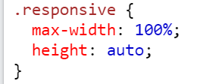

33.WHAT IS FLEBOX.

USING FLEXBOX WE CAN ACHIEVE RESPONSIVE LAYOUTS WITHOUT USING POSITIONS,FLOAT AND INLINE-BLOCK.

**FLEX CONTAINTER PROPERTIES WE CAN USE**flex-direction

flex-wrapflex-flow

justify-content

align-items

align-content

**FLEX-CHILD PROPERTIES ARE WE CAN USE**

order

flex-grow

flex-shrink

flex-basis

align-self

# 34. SET FLEX ITEMS INTO EQUAL WIDTH COLUMNS USING CSS

# FIRST WAY

|  |  |
| --- | --- |
| HTML | CSS |
| <div class="row"><div class="item">one</div><div class="item">two</div><div class="item">three</div></div> | .row{display: flex;} .item{background-color: green;width:100%;} |

SECOND WAY:

|  |  |
| --- | --- |
| HTML | CSS |
| <div class="row"><div class="item">one</div><div class="item">two</div><div class="item">three</div></div> | .row{display:flex;}.item{background-color:green;flex-grow:1;} |

35. APPLY BACKGROUND COLOR FOR SECOND DIV

|  |  |
| --- | --- |
| HTML | CSS |
| <div>one</div><div>two</div><div>three</div> | div: nth-child(2){background-color:green;} |

**36.WHAT IS TRANSISTION?**

CSS TRANSITIONS ALLOWS YOU TO CHANGE PROPERTY VALUES SMOOTHLY BY USING DURATION.

**37.WHAT IS MEDIA QURIES?**

TO ACHIEVE RESPONSIVE WEB DESIGN WE CAN USE MEDIA QUERIES.

**38.DO YOU HAVE EXPERIENCE RESPONSIVE?**

**YES**

**39.CLEAR:BOTH PROPERTY?**

**USING “CLEAR:BOTH” PROPERTY IS PUSHED BELOW BOTH LEFT AND RIGHT FLOATED ELEMENTS**

**40.WHAT IS THE WIDTH OF DIV?**

**div{**

**width:300px;**

**padding:5px;**

**border:5px;**

**margin:5px;**

**height:300px;**

**}  
  
300PX(WIDTH)+10PX(PADDING-LEFT+PADDING-RIGHT)+10PX(BORDER-LEFT+BORDER-RIGHT)+10PX(MARGIN-LEFT+MARGIN-RIGHT)=330PX**

**41.CSS BOX-SIZING**

BOX-SIZING PROPERTY ALLOWS US INCLUDE PADDING AND BORDER IN ELEMENTS TOTAL WIDTH AND HEIGHT.

BOX-SIZING CONTAIN TWO PROPERTIES

**1.CONTEXT BOX**

If you set box-sizing: content-box; on an element, padding and border are not included in the width and height.

**2.BORDER BOX**

If you set box-sizing: border-box; on an element, padding and border are included in the width and height.

**42.DISPLAY CIRCLE HORIZONTALLY AND VERTICALLY USING CSS**

|  |  |
| --- | --- |
| **HTML** | **CSS** |
| **<div>**  **</div>** | **div{**  **width:100px;**  **height:100px;**  **border-radius:50%;**  **position:absolute;**  **top:50%;**  **left:50%;**  **transform: translate(-50%,- 50%);**  **border:3px solid red;**  **background:green;**  **}** |

**43.PADDING REALATED QUESTION**

|  |  |  |  |  |
| --- | --- | --- | --- | --- |
| **PADDING** | **10PX** | **20PX** | **30PX** | **40PX** |
|  | **TOP** | **RIGHT** | **BOTTOM** | **LEFT** |

|  |  |  |
| --- | --- | --- |
| **PADDING** | **10PX** | **20PX** |
|  | **TOP** | **RIGHT** |

**44.DEFINE IMAGE SPRITES**

* **IMAGE SPRITES IS A COLLECTION OF IMAGES PUT INTO SINGLE IMAGE.**
* **A WEBPAGE WITH MANY IMAGES CAN TAKE LONG TIME TO LOAD AND GENERATES MULTIPLE SERVER REQUEST.**
* **USING IMAGE SPRITES WILL REDUCE THE NUMBER OF SERVER REQUESTS AND SAVE BANDWIDTH.**

**42.DISPLAY CIRCLE HORIZONTALLY AND VERTICALLY USING CSS WITH MEDIA QUERY.(BETWEEN 500 AND 700 CHANGE COLOR).**

|  |  |
| --- | --- |
| **HTML** | **CSS** |
| **<div>**  **</div>** | **div{**  **width:100px;**  **height:100px;**  **border-radius:50%;**  **border:3px solid red;**  **background:green;**  **} @media only screen and (min-width: 500px) and (max-width:700px) {**  **div{**  **background:red;**  **}**  **}** |

**43.HOW TO CREATE 4 COLUMN RESOPONSIVE LAYOUT?**

|  |  |
| --- | --- |
| HTML | CSS |
| <div class="parent"><div>one</div><div>two</div><div>three</div></div> | .parent{display:flex;}.parent>div{width:100%;height:100px;background:green;margin:10px;} |

**44.WHAT IS CSS VARIABLE**

**USING CSS VARIABLE WE CAN CREATE VARIABLES WITH LOCAL OR GLOBAL SCOPE.CHANGE VARIABLES WITH JAVASCRIPT AND BASED ON MEDIA QUERIES.**

**:root {**

**--blue: blue;**

**--white: white;**

**}**

**body {**

**background-color: var(--blue);**

**}**

**45.CSS ORIENTATION EXAMPLE**

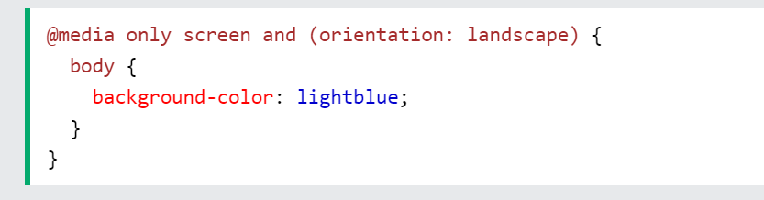

**46.WHAT IS MOBILE FIRST APPROACH?**

**MOBILE FIRST APPROACH MEANS BUILDING WEBSITES FOR MOBILE DEVICES AND THEN USE CSS MEDIA QUERIES FOR LARGER ONES LIKE DESKTOP OR TABLET.**

**47.CSS LIMITATIONS**

**BROWSER COMPATABILITY**

**CSS DOES NOT HAVE BUILT IN SECURITY**

**48.SHOW ME ELIPSIS EXAMPLE**

|  |  |
| --- | --- |
| **HTML** | **CSS** |
| **<p>This is some long text that will not fit in the box</p>** | **p {**  **white-space: nowrap;**  **width: 200px;**  **border: 1px solid #000000;**  **overflow: hidden;**  **text-overflow: ellipsis;**  **}** |

**49.DEFAULT POSITION VALUE**

**STATIC**

**50.FLEX-BASIS**

**FLEX-BASIS PROPERTY SPECIFIES THE INITIAL LENGTH OF FLEX ITEM**

**51.HOW TO TARGET SPECIFIC OUTLOOK EMAIL.**

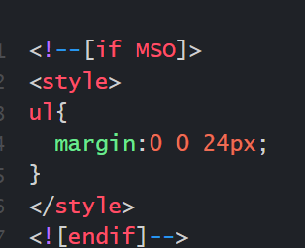

**52.FATHER OF CSS**

**HAYKON WIUM LIE**

**53.CSS FUNCTIONS**

**CALC()**

**MAX()**

**MIN()**

**URL ()**

**RGB()**

**VAR()**

**54.HOW TO FLIP TEXT OR REVERSE TEXT USING CSS**

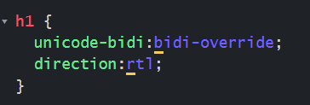

**OR**

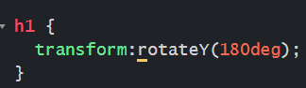

**55.HOW TO USE CALUCULATIONS USING CSS**

**USING “CALC” PROPERTY.**

**56.CSS UNITS**

**THERE ARE TWO TYPES OF UNITS.**

**1.ABSOLUTE**

**2.RELATIVE**

**ABSOLUTE UNITS**

**CM-CENTIMETERES**

**MM-MILLI MITERS**

**IN-INCHES**

**PX-PIXELS**

**PT-POINTS**

**PC-POINTS**

**RELATIVE UNITS**

**EM**

**EX**

**CH**

**REM**

**VW**

**VH**

**VMIN**

**VMAX**

**%**

**57.HOW TO USE ANIMATIONS USING CSS**

**WE CAN DO ANIMATIONS USING KEYFRAMES**

**58.WHAT IS STYLEGUIDE**

**STYLE GUIDE MEANS WE HAVE TO FOLLOW SOME GUIDE-LINES**

* **NAMING CONVENTIONS**
* **FORMATING AND INDENTATION OF CSS CODE**
* **USE COMMENTS AND DOCUMENTATION**
* **USE SHORT HAND PROPERTIES**

**59.TRANSFORM**

**USING CSS PROPERTY WE CAN USE 2D AND 3D TRANSFORMATION METHODS.**

**TRANSLATE()**

**ROTATE()**

**SCALE()**

**SKEW()**

**60.HOW TO SPLIT TWO COLUMNS USING CSS**

**WE CAN USE DISPLAY GRID AND GRID-TEMPLATE-COLUMN PROPERTY 50% 50%;**

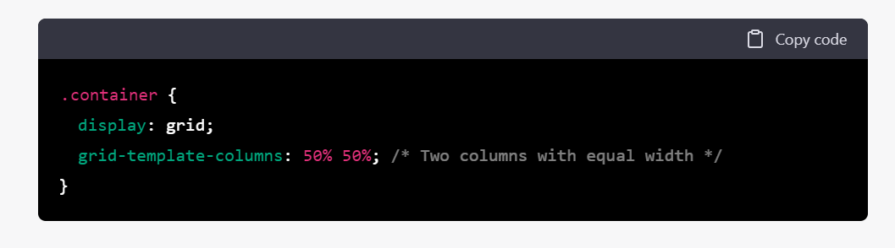

**61.HOW TO APPLY CSS RADIO BUTTONS**

**WE CAN USE “INPUT[TYPE=’RADIO’]”.**